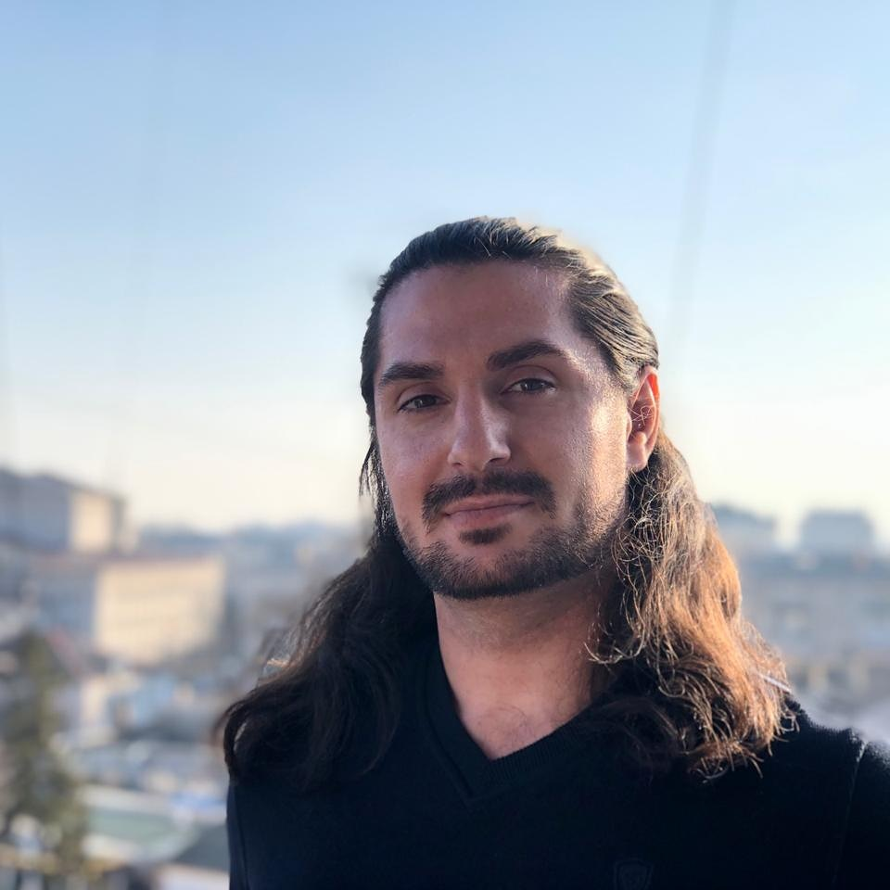
Levan Melkonia
Junior Python Developer
Contact Information
E-mail: levan.melkonian@gmail.com
Mobile phone : +38 (098) 123-666-9
GitHub: github.com/Leon047
Skype: leon03215
Summary
Skills | Programming languages  - Python (oop, fp)  - SQL  - HTML/CSS (Advensd)  - JavaScript (Advensd)  Development Tools  PyCharm, Vim, PyQt,  Visual Studio, Visual Studio code  Version control  Git (GitHub/GitLab)  OS  GNU/Linux (Debian, Ubuntu, Arch)  - Bash Scripting  Windows (7, 10)  Languages  - Georgien (Native)  - Russien (Second native)  - English (Advensd, Intermediate)  - Ukraine (Understand, but do’t speak) | Framework  Flask, Scrapy  Methodologies  Scrum, Kanban,  Pair Programming  RDBMS  PostgreSQL, MySQL, SQLite  Virtualization  Docker/Docker-compose  Virtual environment (Venv)  Data formats  XML, HTML, JSON
Education | 2019 Interregional Academy of Personnel Management.  Faculty of Computer Information Technologies.  Specialty: applied programming  Graduated with honors.
Achievement | 28/30.11.2017 Kyiv, Ukraine  - Microsoft Developer School Certificate.  05.14/09.10.2019 SoftServe IT Academy  - Quality assurance and testing of modern software systems certificate.

Work experience | 10/09/2019 SoftServe Academy graduate project.  EASY-REST website automation testing with Selenium WebDriver for CI/CD.  2018/2020  Testing code with PyTest and Unittest.  Writing code with http requests for web scraping.  Writing and working on a database query for data management.  Building simple Flask applications in Docker.
About myself | Hi, I'm Leo and I'm a junior Python developer, because I don't have a multi-faceted project  development experience. I have no illusions, and I understand that if you want to improve  your skills and be successful in your business, you need to make every effort and devote  most of your time to it.  P.S. Developer is not a profession, it's a lifestyle! \m/  Virtues  - Responsibilityс  - Self-confidence  - Honesty  - Responsiveness  - Politeness  - Sincerity  - Zeal  - Optimism  Hobby  - Reading books  - Rock music \m/  - Painting  - Basketball  - Robotics

